Christopher Wilson
7/20/2026
CS-660 Module Three Activity
- Identify the type system used in the provided language.
The provided language is Python. Python uses a dynamic, strongly typed type system. Dynamic typing means that the variables do not have a fixed type, and Python determines the type of variable at runtime rather than before the program starts. An example would be a variable that can store an integer that could be reassigned to a string later on without causing an error (“Type Systems”, 2019). Python is also strongly typed, which means that it doesn’t automatically convert incompatible types during operation. If you try to add an integer to a string, Python will raise a type error instead of attempting to convert one of the values to a different type (Martins, 2024).

- Modify the code to demonstrate type mismatches that violate the language’s typing rules.
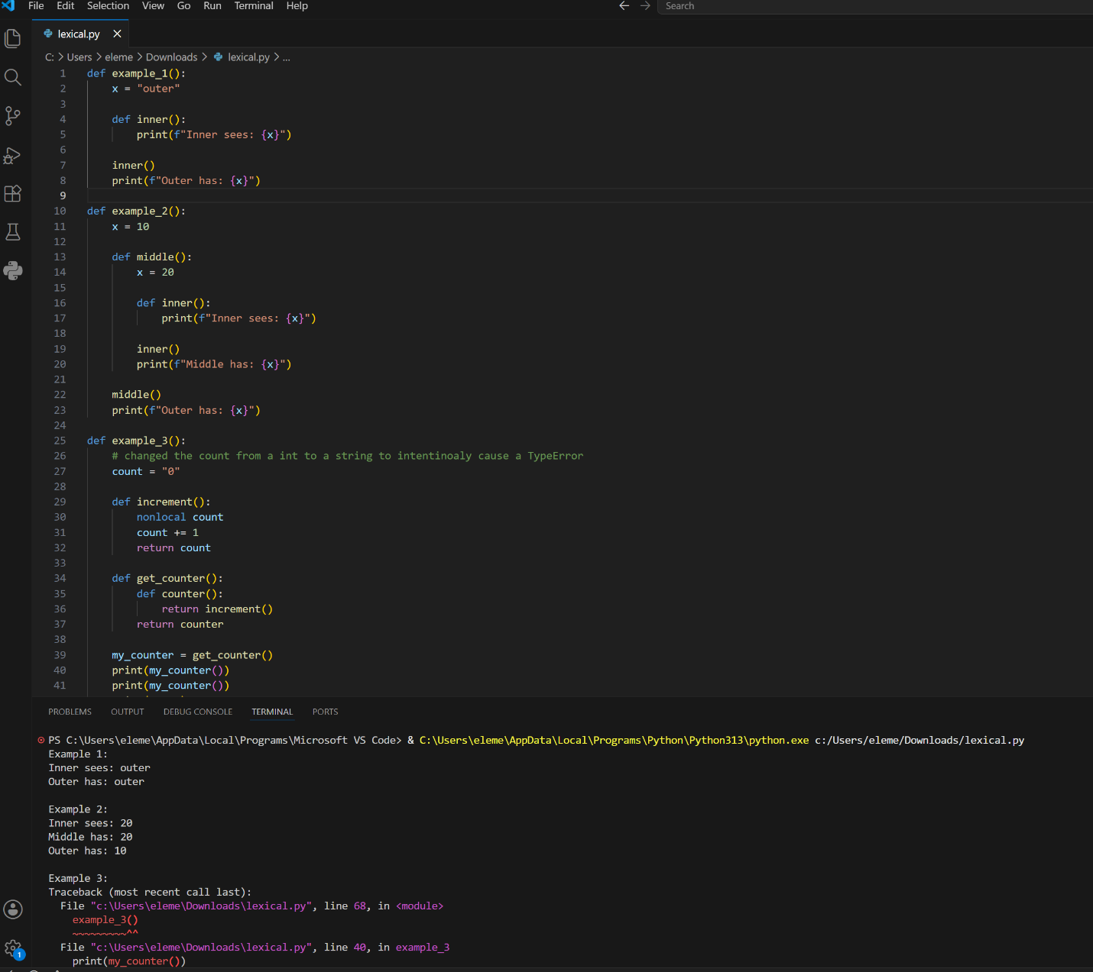
Caused a type error by changing the count to a string. Causes a type error because it tries to add an int and a string.

- Explain the compiler or interpreter behavior that results from the type mismatches in the modified code.
Python is primarily an interpreted language, so type checking happens during runtime instead of during compile-time. When the modified code reaches the line count += 1, the interpreter checks the types in the operation. Since count is a string and 1 is an integer, Python sees that these two data types cannot be added together. Because Python uses strong typing, it does not automatically convert the string into an integer. Instead, the interpreter raises a type error and stops the program at that line. Since the program can run until it reaches the operation with incompatible types, this shows that Python detects these type errors while the program is executing rather than before the program starts (“Difference between compiler”, 2025).
- Correct the type mismatches in the code to align with the language’s rules for static or dynamic typing.
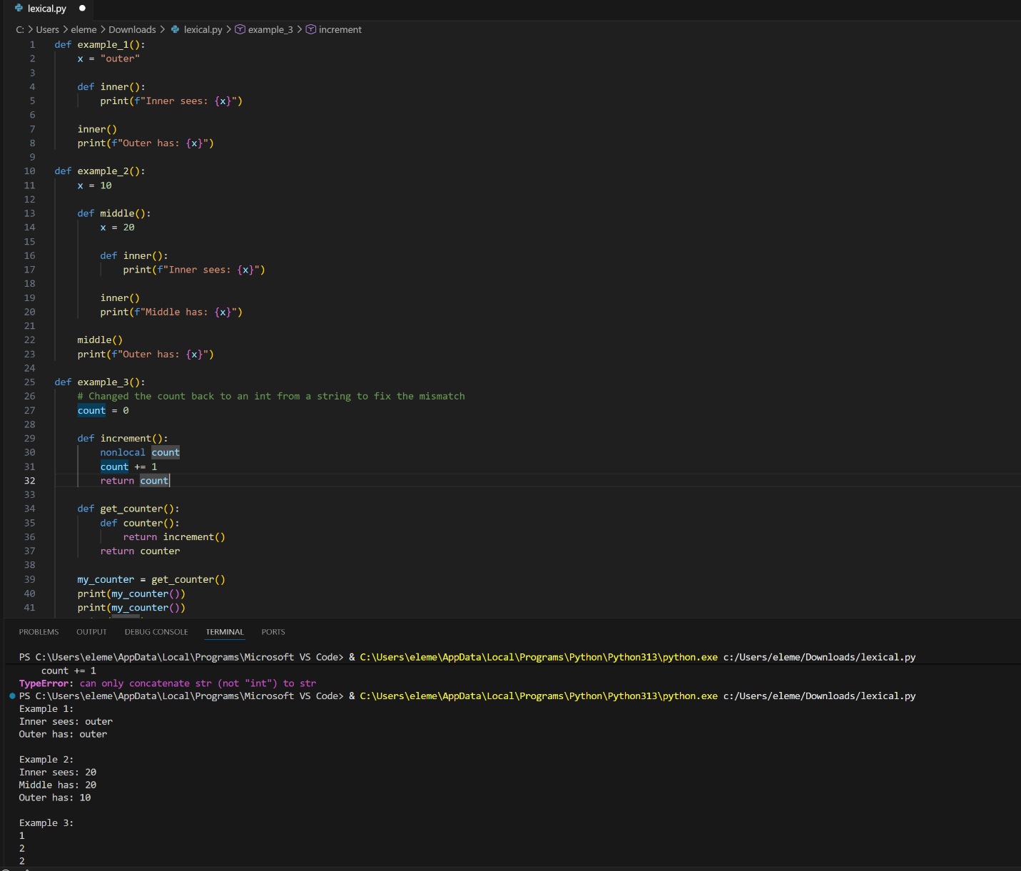
Fixed the type mismatch by reverting the code to the original state before changing the count to a string type.

- Compare how the language handles typing at runtime versus compile-time.
Python handles typing at runtime because it is a dynamically typed language. This means Python determines the type of a variable while the program is running. Type errors are only found when the program reaches an operation that uses incompatible types. In the modified code, Python allows count to be changed into a string, but when it reaches count += 1, it detects that a string and an integer cannot be added together and gives a TypeError. In comparison, statically typed languages check variable types during compile-time before the program runs. For example, in Java, assigning a string to an integer variable would cause an error before the program could execute. Runtime typing makes Python more flexible because variables can change types, while compile-time typing catches errors earlier and helps prevent type-related problems before the program runs (Komilov, 2024).

- Describe how the type system affects code clarity, flexibility, and error prevention.
Python's dynamic type system affects code clarity, flexibility, and error prevention in different ways. Since Python does not require variables to have a declared type, it allows developers to write code more quickly and gives variables the flexibility to store different types of values. However, this can sometimes make code less clear because the type of a variable is not always obvious when reading the program. Python's strong typing helps prevent errors by stopping invalid operations between incompatible types, but because type checking happens at runtime, some errors may not be found until the program is executed. Overall, Python provides more flexibility, while statically typed languages usually provide stronger error prevention by detecting type issues earlier (Python, 2019).

- Run the code to demonstrate lexical scoping using nested functions.
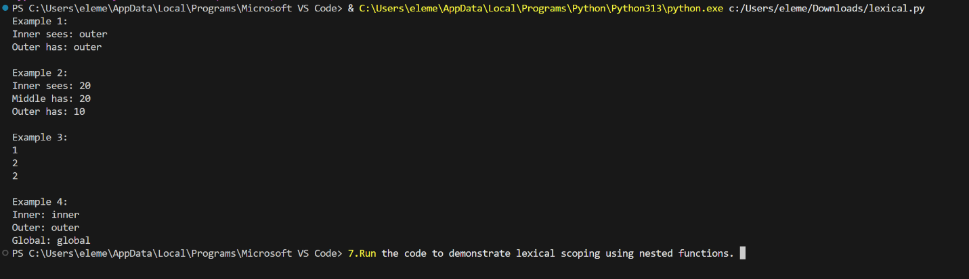
After running the code, it demonstrates lexical scoping because the variables are resolved based on where the nested functions are defined. In Python, the inner functions look for variables in their local scope first, then move outward through the enclosing scopes using the LEGB rule. For example, in Example 2, the inner() function uses the value of x from the middle() function because that is the closest enclosing scope where x is defined. It does not use the x value from the outer function. This shows that Python determines variable resolution by the structure of the code rather than the order in which functions are called.

- Modify the code to simulate dynamic scoping.
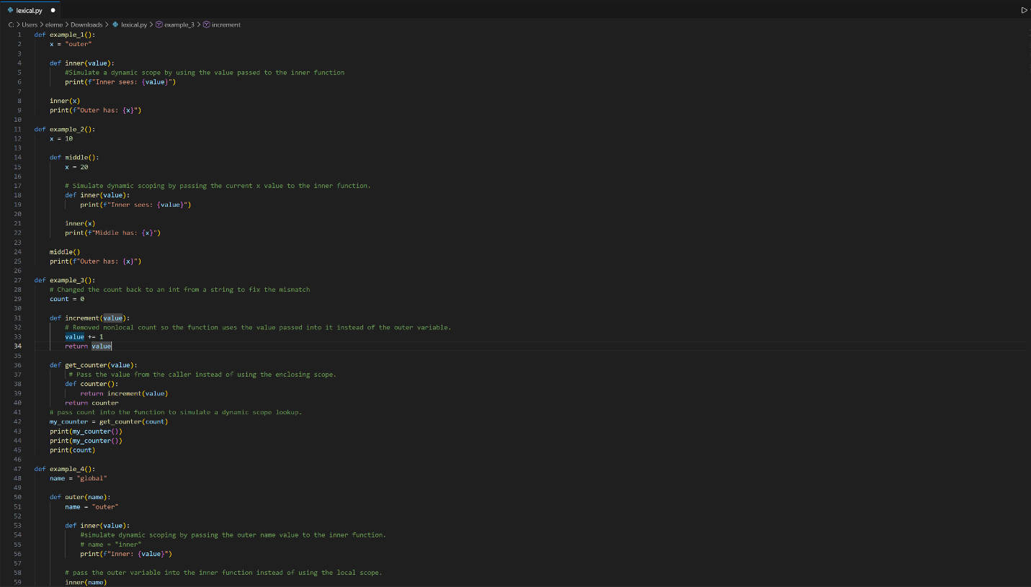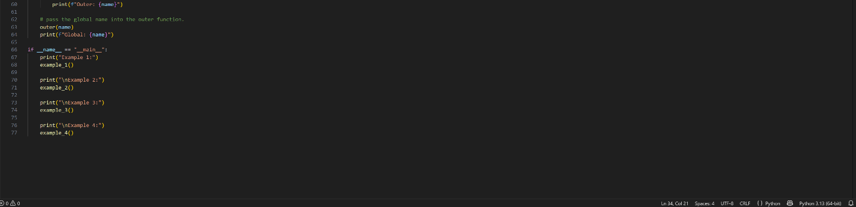
- Trace how variable values are resolved in both lexical and simulated dynamic scoping. Include the following:
- In-line comments
In the original code, Python uses lexical scoping, which means variables are resolved based on where the function is created. For example, in example_2(), the inner() function uses the x value from the middle() function because inner() is inside middle(). This causes inner() to see the value 20. In the modified code, dynamic scoping is simulated by passing the variable value into the function. Instead of looking for the variable in the surrounding functions, the function uses the value that was passed by the calling function. This causes the variable value to come from the function that called it instead of where the function was defined. The inline comments in the code show where the variable was passed and how the value was resolved.

- Compare the outcomes. Include the following:
- How each scoping rule affects predictability and readability
The outcomes were different between lexical scoping and simulated dynamic scoping. In the original code, Python used lexical scoping, meaning variables were resolved based on where the function was created in the source code. In example_4(), the inner function used its own name variable, which caused the output to be Inner: inner, Outer: outer, and Global: global. After modifying the code to simulate dynamic scoping, the output changed to Inner: outer, Outer: outer, and Global: global because the inner function used the value passed from the calling function instead of its own variable. Lexical scoping makes programs easier to understand and debug because variables are predictable based on the code structure. Dynamic scoping is more dependent on the order of function calls during execution, which can make the program harder to follow because the variable value depends on the current execution path. Overall, lexical scoping is usually preferred because it provides better readability, predictability, and easier maintenance (“Static and Dynamic”, 2026).

- Evaluate which scoping model would be preferable in different programming contexts.

Lexical scoping is the better choice for most programming situations because it makes code easier to understand and maintain. Since variables are based on where the function is written, developers can look at the code and know which variable will be used. This makes debugging easier and reduces unexpected behavior. Dynamic scoping can be useful when a program needs more flexibility because variables can come from the function that calls another function. However, it can make the code harder to follow because the variable value depends on the order of function calls during runtime. Overall, lexical scoping is better for larger projects because it improves readability, predictability, and error prevention, while dynamic scoping is only useful in situations where runtime flexibility is more important (“Static and Dynamic”, 2026).

Sources

GeeksforGeeks. (2017). Static and dynamic scoping. In GeeksforGeeks. https://www.geeksforgeeks.org/dsa/static-and-dynamic-scoping/

GeeksforGeeks. (2019). Type systems:Dynamic typing, static typing & duck typing. In GeeksforGeeks. https://www.geeksforgeeks.org/python/type-systemsdynamic-typing-static-typing-duck-typing/

GeeksforGeeks. (2020). Difference between compiler and interpreter. In GeeksforGeeks. https://www.geeksforgeeks.org/compiler-design/difference-between-compiler-and-interpreter/

Martins, S. (2024). Understanding Python’s weak and strong typing: A comprehensive guide. In Medium. The Pythoneers. https://medium.com/pythoneers/understanding-pythons-weak-and-strong-typing-a-comprehensive-guide-c7ec805b3a92

Type system concepts — typing documentation. (2019). In Python.org. https://typing.python.org/en/latest/spec/concepts.html

Yodgorbek Komilov. (2024). Understanding compile time and runtime in Programming. In Medium. https://medium.com/@YodgorbekKomilo/understanding-compile-time-and-runtime-in-programming-a001a40f1c27

OpenAI. (2026). ChatGPT (GPT-5.5, July 20 version) [Large language model]. https://chatgpt.com
ChatGPT used to help find sources, and help understand some concepts, and help with coding the dynamic simulation.

